1. Aim: Design Turing Machine using simulator to accept the input string ww over input alphabets ∑ = {a, b}.

Diagram:

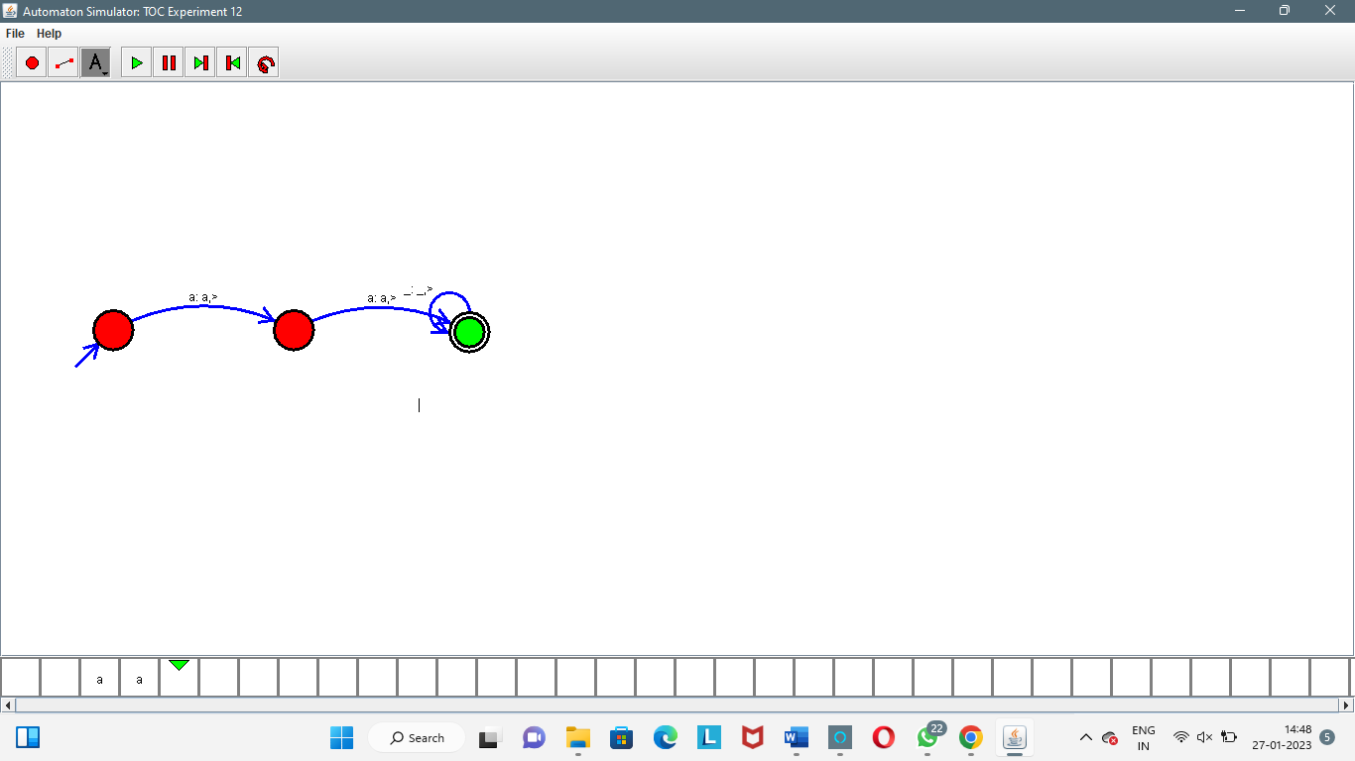

Result:

Successfully executed Turing Machine using simulator to accept the input string ww over input alphabets ∑ = {a, b}.